Disclaimer: This tutorials’ answers + notes are not exhaustive, Please contribute. It will be subject to change in the future.

Tutorial 1- Intro to Cloud

The definition of cloud computing is :
Cloud Computing is a model for enabling ubiquitous, convenient, on-demand network access to a shared pool of configurable computing resources (e.g., networks, servers, storage, applications, and services) that can be rapidly provisioned and released with minimal management effort or service provider interaction.

The six essential characteristics of cloud computing :
- On-Demand Usage: consumers can use the cloud features on an on-demand basis, they can self provision the IT resources made available to them.
- Ubiquitous Access: Users could interact with the cloud from a range of platforms (phone, computer etc.).
- Multitenancy: Cloud service provider allows one instance to serve different (isolated customers) via virtualisation technologies. This allows the efficient use of its IT resources since these resources can be dynamically assigned.
- Elasticity: automated ability of cloud service to transparent scale IT resources, as required in runtime-condition or predetermined by cloud consumers and cloud providers.
- Measure Usage: ability to keep track of the usage of IT resources, primarily by cloud consumers. Closely related to on-demand characteristic.
- Resilience: Cloud is fail safe. Users could access and interact with the cloud even when one data center is affected (power outage, natural disaster etc.) since the data is duplicated across multiple physical locations.

Four deployment of cloud computing:
- Public Cloud: Low cost, however, there are privacy concerns.
- Private Cloud: High cost, highly customisable.
- Community Cloud: much like private cloud, but own by a group rather than a single organisation
- Hybrid Cloud: This type of cloud consists of two or more distinct cloud infrastructures which are bounded by standard or proprietary technologies.

Cloud Delivery Models:
- Iaas (Infrastructure as a service): Users have full access to the virtualized infrastructure. (Virtual machines, EC2 etc.)
- PaaS(Platform as a service): Users have moderate level of control, the platform skeleton is pre-configured by the service provider. (Google app engine etc.)
- SaaS(Software as a service): Users could only configure usage related features and have access to the front end interface. (Netflix, dropbox, icloud etc.)

Tutorial 2 - Intro to Cloud II

1. What are cloud-enabling technologies(EXAM QUESTION)?
- Broadband network and internet architecture: internet architecture is the backbone of the cloud services, no cloud without internet.
- Virtualisation Technology: process of converting a physical IT resource into a virtual IT resource.
- Data centre technology: a special IT infrastructure houses centralised IT resources
- Web technology: used for cloud service implementations and for front-ends used to remotely manage cloud-based IT resources.
- Multitenant technology: enables multiple users to access the same program whereby each is isolated from each other.

2. Virtualisation Technology

Definition: process of converting a physical IT resource into a virtual IT resource

Physical server: host / physical host

Virtual Machine Monitor (VMM) / hypervisor: a software that manages VMs and hardware

Guest OS: an OS in a virtual machine

Steps of creating a new virtual server through virtualisation software:
1. the allocation of physical IT resources (e.g. specify #CPU, Mem, Storage in VirtualBox by Oracle);
2. followed by the installation of an operating system (e.g. Install Ubuntu or Windows systems in VirtualBox).

- Hardware Independence
- Convert and translate IT hardware into emulated and standardised software-based copies
- Cloning & manipulating virtual IT resources is easier than duplicating physical hardware

- Server Consolidation
- Enables different servers to share one physical server
- Used to increase hardware utilisation, load balancing, and optimisation of available IT resources

- Resource Replication
- Virtual servers are created as virtual disk images that contain binary files copies of hard disk content
- These disk images perform copy, move and paste for replication, migration and back up the virtual server

- Operating System-Based Virtualisation
- Installation of virtualisation software in a host operating system

- Hardware-Based Virtualisation
- Installation of virtualisation software directly on the physical host hardware bypassing the host OS

3.What is amazon’s EC2 and what are its benefit

4.Difference between container and virtual machine

A VM is a software-based environment geared to simulate a hardware-based environment. Container technology offers the opportunity to virtualise the operating system itself. Docker container looks like a VM, but a docker container is much lighter than VM. Docker containers could share the same OS kernel while a VM is virtualising a dedicated operating system.
Features | Containers | VM
Start-time | In seconds | In minutes
Disk size | Normally in MB | GB
Efficiency | Fast (close to native) | Very slow
Runnable instances (on one physical server) | More than 1k | Normally 10 +

*Multitenant Technology
Definition: enable multiple users (tenants) to access the same application logic simultaneously.
- Each tenant has its own view of the application as a dedicated instance of software
- Ensure tenant do not have access to data and configuration not of their own

*Multitenancy vs Virtualisation
Virtualisation is that multiple virtual copies of the server environment can be hosted by a single physical server. Each copy can be provided to different users, can be configured independently, and can contain its own operating systems and applications.

Multitenancy is a physical or virtual server hosting an application designed to allow usage by multiple different users. Each user feels as though they have exclusive usage of the application.

*Containerisation
The process of taking an application and configuring it to run as a container

Similarities | Dissimilarities
Both VM and containers adopts virtualisation technology | Container | VM
Both VM and containers are performing data segregation, but in different environment | All containers share the same OS kernel | Each VM machine has its dedicated OS
 | OS virtualization | Hardware-level virtualization
 | Fast startup | Slower startup

Tutorial 3 - Docker I

1. What is docker ? Discuss the motivations of using docker technology ?
Docker is a set of platforms as a service product that uses OS-level virtualisation to deliver software packages called containers in a loosely isolated environment.

Docker allows you to separate your application from your infrastructure to deliver software quickly.

2. Docker image, docker container and docker registries. Please give some brief descriptions ?
Docker image: The image is a read-only template with instructions for creating containers.
Docker container: A container is a runnable instance of an image.
Docker registry: A docker registry that stores images.
Docker compose: A tool for defining and running multi-container Docker applications
Docker swarm: Manage multiple containers deployed across multiple host machines.
Docker machine: A tool to install docker engine (docker) on virtual hosts.
Kubernetes: k8s in short. Like docker swarm, it is an orchestration tool. It has the characteristics of: High availability, load balancing, auto-healing, scaling.

3. What is a dockerfile? What are the good practices of writing a dockerfile ?
Dockerfile is a text file that contains instructions and commands for building a docker image and running as a container.
Good practices:
- Minimize the number of layers.
- Decouple applications.
- Don’t install unnecessary packages.

4. How to make a docker image built from a docker file as lean as possible ?
By explicitly stating the only the software packages required for your desired functions and make sure there are no unnecessary softwares defined in the dockerfile.

- Import a base image with a smaller footprint
- Install only necessary dependencies
- Use cleanup commands
- Multi-stage builds

* Microservices

Definition: an architectural and organizational approach to software development where software is composed of small independent services that communicate over well-defined APIs.
Pros | Cons
Technological freedom (Language independent) | Infrastructure Overhead (servers and databases)
Easy deployment (fast iterations & reusable code) | Complicated networking

Agility (small teams)

Resilience (Fault isolation)

Flexible Scaling (scalable)

*Orchestration

Definition: automated configuration, management, and coordination of computer systems, applications, and services.

Tools to manage, scale, and maintain containerised applications are called orchestrators

Examples: Apache Mesos, Kubernetes, and Docker Swarm.
*Kubernetes (commonly stylised as K8s)

Definition: open-source container-orchestration system for managing (deploying and scaling) containerised applications across multiple hosts
- provides automating deployment, scaling and management of containerised applications.

Tutorial 4 - Docker II

What are desirable features of Distributed File System(DFS) ?
Transparency
- Access transparency
- Location transparency
- Concurrency transparency
- Failure transparency
- Replication transparency
- Migration transparency

Heterogeneity: the file service should be provided across different hardware and operating system platforms.

Scalability: the file system should work well in small environments.

What is a clustered File System ? Please use one sentence to answer this question ?
The clustered file system is a system with a cluster of servers that work together to provide high performance service to their clients.

Compare and contrast DFS NFS and CFS
DFS:

NFS:

CFS: unified namespace, the client does not see physical boundaries between machines.

GFS Operations (Read and Write)
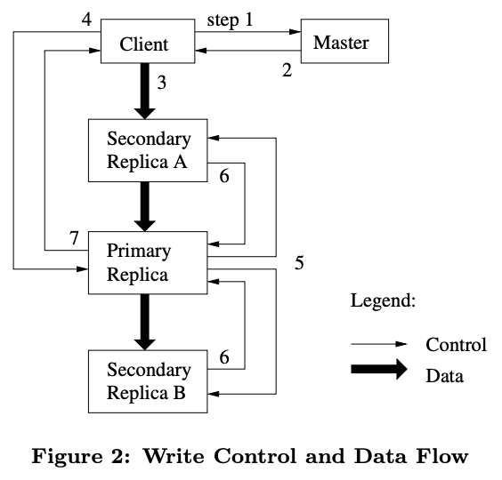

Write
- Client interact with the master to ask which chunk server holds the lease (primary replica) and location of the other replicas (搵大佬， 搵细佬,准备落order）
- Master replies to the client with the identity of primary and secondary replicas (話俾client知大佬係邊個同細佬喺邊度)
- Client pushes data to all replica (client落order比大佬同細佬)
- Once all replicas have acknowledged receiving the data, client sends write request to primary (全部人同client话收到order，client叫大佬做嘢)
- Primary forwards write request to all secondary replicas (大佬叫细佬做嘢)
- Secondary replicas reply to primary indicating they have completed operation (细佬同大佬讲做完嘢)
- Primary replies to the client with success or error message (大佬回client成功地或者失败地做完嘢)

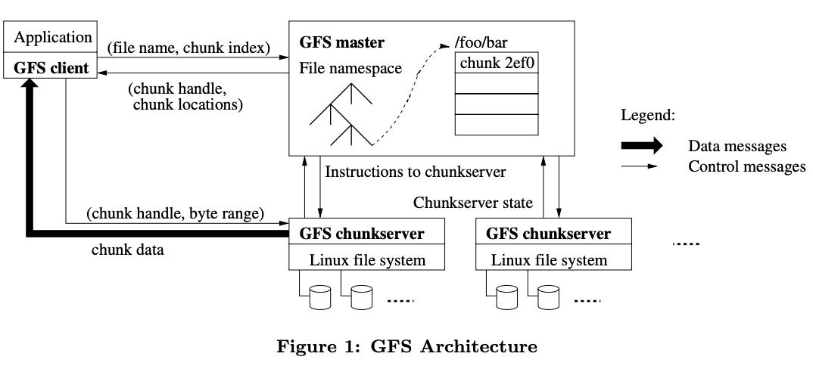

Read
- When the application is reading a file, the application needs to go through GFS client, the client can send file name and chunk index to GFS master.

- After receiving the request, the GFS master will check its table and return the chunk handle and all the chunk server IP addresses (locations) where that chunk has the replicas.

- The client caches this information using the file name and chunk index as the key. The client then sends a request to one of the replicas, most likely the closest one. The request specifies the chunk handle and a byte range within that chunk.

- The chunk server will send the requested data to the client, and thus requiring no more client-master interactions until the cached information expires or the file is reopened.

- The client forwards the data to the application.

Tutorial 5

1.What is Big Data? Please discuss how we can address Big Data processing.
Volume
Variety
Velocity

Data must be processed with
Data mining and machine learning using machine learning library or data analytic engine like spark
Cloud computing

2.What is Apache Spark and how does it compare with Apache Hadoop?

Spark | Hadoop
In-memory computation | Relies on disk read write
Supports Python, R, Scala | Only support Linux
Supports caching | N/A
Supports batch/real time processing | Batch processing

3. What is resilient distributed datasets(RDD）
Resilient data structure is immutable distributed collection of objects. It is the fundamental data structure of spark. Each dataset in RDD is divided into logical partitions which may be computed on different nodes of the cluster. (parallel computing)

There are 2 main ways of creating RDD:
Parallelise
Reference dataset from an external storage system.

4. Please discuss how Spark works?
RDD -> DAGScheduler (DAG is the underlying mechanism for achieving rdd’s fault tolerance) -> task scheduler -> worker

*Lazy evaluation

Definition: When a transformation on an RDD is called, the operation is not immediately performed.

Spark internally records metadata to indicate that this operation has been requested.

Spark can decide what the best way is to perform a series of transformations that are recorded.

To reduce the number of passes (storage on disk)

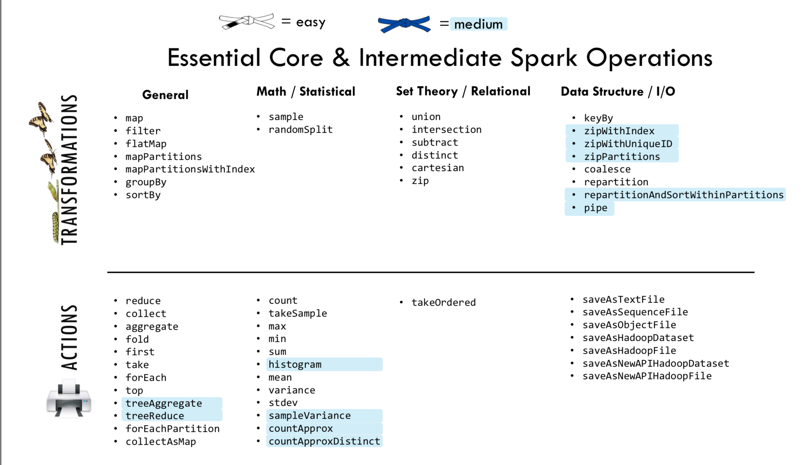

Tutorial 6

1. What’s the difference between textFile and parallelize methods ?
textFile is the command to reference datasets from an external storage system.
Parallelize method is used to parallelize an existing collection.

2. Can key/value pair be duplicated ?
Spark allows the duplication of key/value pairs so aggregations functions can be performed to obtain statistics of RDDs.

3. Please describe what an aggregate function is ?
The aggregation function : average, count, max, min, median, mode , range sum.
The aggregation functions are the functions where multiple records are grouped together. As an example, mode of the dataset is the datum that exists the most in the dataset.

4. Compare reduceByKey and GroupByKey ?
GroupByKey() has no function, while reduceByKey has a reduce function.

reduceByKey returns a pair of RDD of k,v pairs where the values for each keys are aggregated by given reduce function
e.g(x,5)

groupByKey(), on the other hand, returns an iterable of the value has not been reduced()

e.g(x, [1,1,1,1,1])

RDD vs DataFrame

RDD | Dataframe
Immutable distributed collection of elements | Organized into named columns, table like structure in a relational database
Could not run SQL commands | Can run SQL commands
Process large data sets in higher-level data abstraction | Perform atomic transformations and actions operation in lower-level data abstraction
No structure data | Structured data

Tutorial 8
- What is the difference between SQL NoSQL?
SQL databases are primarily called as Relational Databases (RDBMS)
NoSQL databases are primarily called as non-relational or distributed databases.

SQL databases are table-based databases
NoSQL databases are document-based, key-value pairs, graph databases or wide-column stores. This means that SQL databases represent data in form of tables which consist of n number of rows of data whereas NoSQL databases are the collection of key-value pairs, documents, graph databases or wide-column stores which do not have standard schema definitions which it needs to adhere to.

SQL databases have a predefined schema, whereas NoSQL databases have dynamic schema for unstructured data.
- What are ACID properties?
In the context of databases, a sequence of database operations that satisfies the ACID properties is called a transaction.

Atomicity:
Atomicity guarantees that each transaction is treated as a single "unit", which either succeeds completely or fails completely. If any of the statements constituting a transaction fails to complete, the entire transaction fails and the database is left unchanged.

Consistency:
Consistency ensures that a transaction can only bring the database from one valid state to another, maintaining database invariants: any data written to the database must be valid according to all defined rules. This prevents database corruption by an illegal transaction but does not guarantee that a transaction is correct.

Isolation:
Transactions are often executed concurrently. Isolation ensures that concurrent execution of transactions leaves the database in the same state that would have been obtained if the transactions were executed sequentially.

Durability:
Durability guarantees that once a transaction has been committed, it will remain committed even in the case of a system failure. This usually means that completed transactions (or their effects) are recorded in non-volatile memory.

- What are CAP theorem and BASE properties?
In theoretical computer science, the CAP theorem also named Brewer's theorem after computer scientist Eric Brewer, states that it is impossible for a distributed data store to simultaneously provide more than two out of the following three guarantees:\

Consistency:
Every read receives the most recent write or an error.

Availability:
Every request receives a (non-error) response, without the guarantee that it contains the most recent write.

Partition tolerance:
The system continues to operate despite a communication break between nodes (nodes are up, but not communicating).

CP database:
- All clients always have the same view on the data
- Each Client can always read and write’
- The system may not tolerance to failure and reconfiguration
AP database:
- Each Client can always read and write
- The system works well despite the physical partitions
- Clients may have inconsistent views on the data
CA database:
- All clients always have the same view on the data
- The system works well despite the physical partitions
- Clients sometimes may not be able to access data
BASE acronym is used to describe the properties of certain databases, usually NoSQL databases. Opposite to ACID, as ACID refers more towards RDBMS.
(B)asically (A)vailable:
Basic reading and writing operations are available as much as possible (using all nodes of a database cluster), but without any kind of consistency guarantees (the write may not persist after conflicts are reconciled, the read may not get the latest write).

(S)oft state:
Without consistency guarantees, after some amount of time, we only have some probability of knowing the state, since it may not yet have converged.

(E)ventually consistent:
If the system is functioning and we wait long enough after any given set of inputs, we will eventually be able to know what the state of the database is, and so any further reads will be consistent with our expectations.

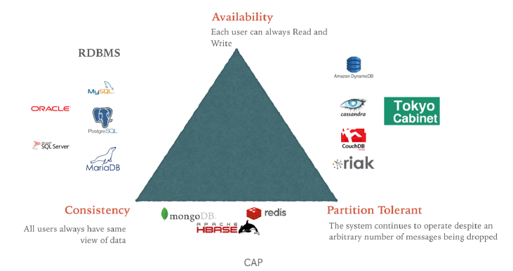

Tutorial 9
- What are Hadoop core components?
Storage: Hadoop Distributed File System (HDFS)
Computation Model: Hadoop MapReduce model.

- Why use Hadoop?
- Process multi petabytes dataset
- Optimized for batch processing
- Cheap commodity hardware
- High scalability and availability
- Fault-tolerance
- Move computation, not data

- What is MapReduce?
MapReduce is the data processing component of Hadoop. It transforms lists of input data elements into lists of output data elements. Big data can be processed through doing map and reduce tasks asynchronouslyI.

- Explain what is shuffling in MapReduce?
The process of transferring data from the mappers to reducers is known as shuffling. MapReduce shuffle phase is necessary for the reducers, otherwise, they would not have any input (or input from every mapper). As shuffling can start even before the map phase has finished so this saves some time and completes the tasks in lesser time.

- What are Hive and Pig? Please compare their differences.
Apache Hive is a data warehouse software project built on top of Apache Hadoop for providing data query and analysis. Hive gives a SQL-like interface to query data stored in various databases and file systems that integrate with Hadoop. Traditional SQL queries must be implemented in the MapReduce Java API to execute SQL applications and queries over distributed data. Hive provides the necessary SQL abstraction to integrate SQL-like queries (HiveQL) into the underlying Java without the need to implement queries in the low-level Java API.

Apache Pig is a high-level platform for creating programs that run on Apache Hadoop. The language for this platform is called Pig Latin. Pig can execute its Hadoop jobs in MapReduce, Apache Tez, or Apache Spark. Pig Latin abstracts the programming from the Java MapReduce idiom into a notation which makes MapReduce programming high level, similar to that of SQL for relational dataBamanagement systems.

Hive vs. Pig
Hive | Pig
Used by Analysts | Used by Programmers and Researchers
Used for reporting | Used for Programming
Declarative SQLish language | Procedural data-flow language
Works on the Server side of a Cluster | Works on the Client side of a Cluster
For Structured Data | For Semi-Structured Data

*Load Balancing
Definition: improves distribution of workloads across multiple computing resources (e.g. computers, computer cluster, network links, central processing units, disk drives).
- Optimize resource use, maximise throughput, minimize response time, avoid overload of any single resource.
What situation needs load balancing?
Server computing capacity problem: The thin clients waged too many applications.
Single-point Data Storage Problem: When a single data resource is (unexpected) demanded by an overwhelming number of clients, (i.e., a single data item is to be requested by many users).
Traffic Problem: When a destination web server is to be visited by too many clients.
Storage and Traffic Problem: When a server needs to maintain far too many incoming data streams (upstream) or outgoing data streams (down streams) for file exchanges.
Network Congestion Problem: When the demands of the (web) services are over the server’s capacity.
Dynamic Change of the Clients Demands: The clients’ demands of services are unpredictable and may change dramatically.

*Load Balancing Algorithm

- Round-robin load balancing
- Distribute client request across a group of servers
- the round-robin load balancer forwards a client request to each server in turn going down the list of servers in the group.
- the load balancer loops back and goes down the list again when it reaches the end of the list (sends the next request to the first listed server, the one after that to the second server, and so on).
- Suitable for clusters consisting of servers with identical specs

- Weighted Round Robin Load Balancing
  - The node with the higher specs will be apportioned a greater number of requests.
  - Set up the load balancer with assigned "weights" to each node according to hardware specs. (Higher specs, higher weight)
- Example:
if Server A capacity is 2x more than Server B, then you can assign Server A a weight of 2 and Server B a weight of 1.

- Least Connections Load Balancing
  - consider the number of current connections each server has when load balancing
  - server with less connection will have higher priority for assignment
- Example:
if Server A has client 5 and 6 connected while Server B has client 2, 4 and 6, client 6 will be directed to Server A instead of Server B.

- Weighted Least Connections Load Balancing
- When directing an access request, a load balancer will consider two things
- The weight of each server
- The number of clients currently connected to each server

- Random Load Balancing
- Matches clients and servers by random using a random number generator
- Able to distribute requests evenly to the nodes even if load balancer receives many requests
- Suitable for clusters consisting of nodes with similar configurations (CPU, RAM, etc).

